Nama : Adridinan Najmi Faza
NIM : H1D025059
Shift Awal/Akhir : B/H
Tugas Akhir

Buatlah sebuah user baru dengan nama anda
MariaDB [(none)]> create user 'najmi'@'localhost' IDENTIFIED BY '111999';
Query OK, 0 rows affected (0.003 sec)
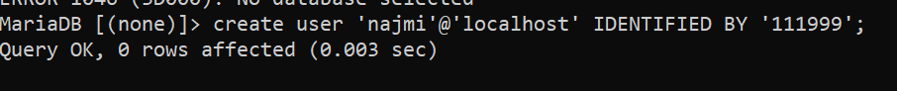

Berikan/Cabut hak akses terhadap user baru tersebut dengan grant insert pada table vendors.
Berikan hak akses
MariaDB [orderentryy]> grant insert on orderentry.vendors to najmi@localhost;
Query OK, 0 rows affected (0.002 sec)

Cek hasil pemberian hak akses dengan melakukan login dan insert/update/delete data table vendors menggunakan user tersebut

Login
LEGION S7@LAPTOP-BJV0VQE3 c:\xampp
# mysql -u najmi -p
Enter password: ******
Welcome to the MariaDB monitor. Commands end with ; or \g.
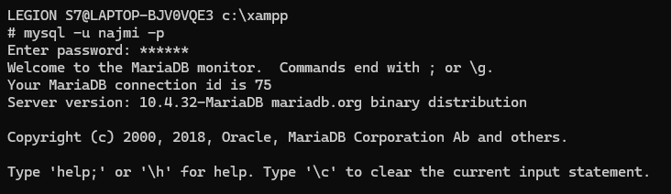
Insert (Bisa)
MariaDB [orderentry]> insert into vendors values
-> ('1052', 'Jaranan COY', '123 ambasing buzz', 'Southfield', 'ID', '22407', 'IDN');
Query OK, 1 row affected (0.002 sec)

Update (Denied)
MariaDB [orderentry]> UPDATE vendors SET Vend_Namee = 'Willy Ganteng' WHERE
-> vend_id = '1052';
ERROR 1142 (42000): UPDATE command denied to user 'najmi'@'localhost' for table `orderentry`.`vendors`

Delete (Denied)
MariaDB [orderentry]> DELETE FROM vendors WHERE Vend_Namee = 'Jaranan COY';
ERROR 1142 (42000): DELETE command denied to user 'najmi'@'localhost' for table `orderentry`.`vendors`

Cabut hak akses tersebut dengan revoke.
MariaDB [(none)]> revoke insert on orderentry.vendors from 'najmi'@localhost;
Query OK, 0 rows affected (0.005 sec)

